**Notes - Ch 6 Continuous Probability Distribution**

**Continuous Probability distribution:**

**Probability density function:** A function used to compute probabilities for a continuous random variable. The area under the graph of a probability density function over an interval represents probability.

The major conceptual difference between discrete and continuous probability distributions involves the method of computing probabilities. With discrete distributions, the probability function f(x) provides the probability that the random variable x assumes various values. With continuous distributions, the probability density function f (x) does not provide probability values directly. Instead, probabilities are given by areas under the curve or graph of the probability density function f (x). Because the area under the curve above a single point is zero, we observe that the probability of any particular value is zero for a continuous random variable.

**Uniform Probability distribution:** A continuous probability distribution for which the probability that the random variable will assume a value in any interval is the same for each interval of equal length.

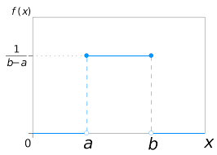

$$f\left(x\right)= \left\{\begin{aligned}\frac{1}{b-a} , a≤x≤b \\ 0 elsewhere\end{aligned}\right.$$

Whenever the probability is proportional to the length of the interval, the random variable is uniformly distributed.

Two major differences stand out between the treatment of continuous random variables and the treatment of their discrete counterparts.

We no longer talk about the probability of the random variable assuming a particular value. Instead, we talk about the probability of the random variable assuming a value within some given interval.

The probability of a continuous random variable assuming a value within some given interval from x1 to x2 is defined to be the area under the graph of the probability density function between x1 and x2. Because a single point is an interval of zero width, this implies that the probability of a continuous random variable assuming any particular value exactly is zero. It also means that the probability of a continuous random variable assuming a value in any interval is the same whether or not the endpoints are included.

The expected value and variance are as follows

$$E\left(x\right)= \frac{a+b}{2}$$

$$Var\left(x\right)= \frac{{\left(b-a\right)}^{2}}{12}$$

**Normal Probability distribution:** A continuous probability distribution. Its probability density function is bell-shaped and determined by its mean μ and standard deviation σ. The normal curve has two parameters, μ and σ. They determine the location and shape of the normal distribution. The normal probability density function is given by

$$f\left(x\right)= \frac{1}{σ\sqrt{2π}}e^{\frac{{-\left(x-μ\right)}^{2}}{2σ^{2}}}$$

**Observations about the normal distribution**

1. The entire family of normal distributions is differentiated by two parameters: the mean μ and the standard deviation σ.
2. The highest point on the normal curve is at the mean, which is also the median and  mode of the distribution.
3. The mean of the distribution can be any numerical value: negative, zero, or positive.
4. The normal distribution is symmetric, with the shape of the normal curve to the left of the mean a mirror image of the shape of the normal curve to the right of the mean. The tails of the normal curve extend to infinity in both directions and theoretically never touch the horizontal axis. Because it is symmetric, the normal distribution is not skewed; its skewness measure is zero.
5. The standard deviation determines how flat and wide the normal curve is. Larger values of the standard deviation result in wider, flatter curves, showing more variability in the data.
6. Probabilities for the normal random variable are given by areas under the normal curve. The total area under the curve for the normal distribution is 1. Because the distribution is symmetric, the area under the curve to the left of the mean is 0.50 and the area under the curve to the right of the mean is 0.50.
7. The percentage of values in some commonly used intervals are:
   1. 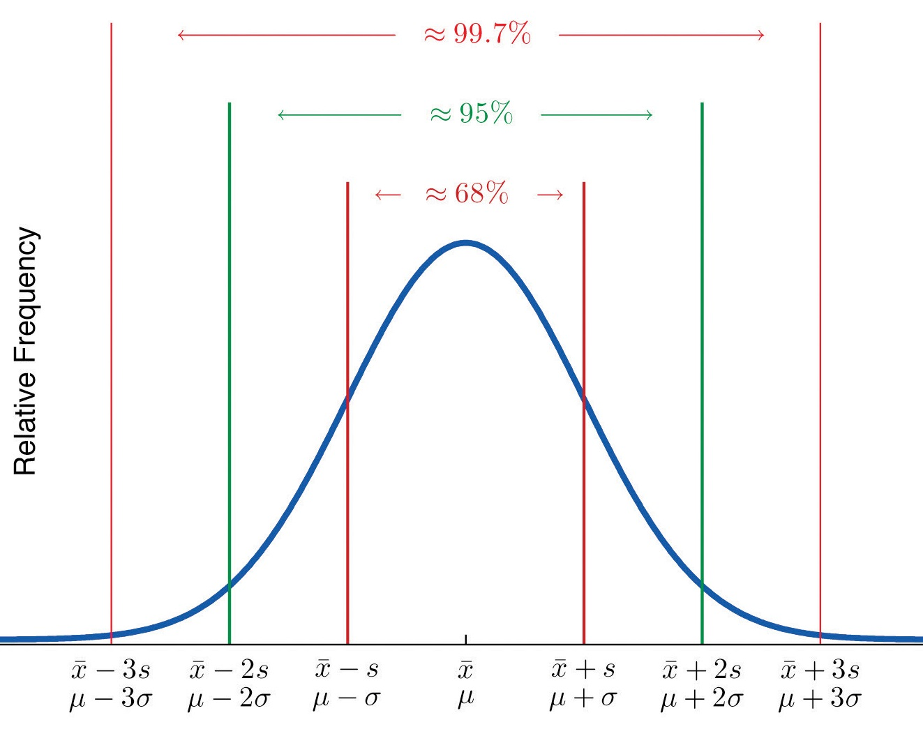68.3% of the values of a normal random variable are within plus or minus one  standard deviation of its mean.
   2. 95.4% of the values of a normal random variable are within plus or minus two  standard deviations of its mean.
   3. 99.7% of the values of a normal random variable are within plus or minus three  standard deviations of its mean.

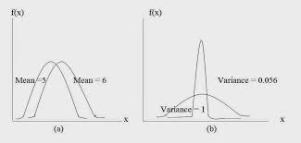

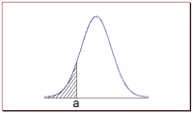The probability that a normal random variable X equals any particular value is 0.

The probability that X is greater than *a* equals the area under the normal curve bounded by *a* and plus infinity (as indicated by the non-shaded area in the figure).

The probability that X is less than *a*equals the area under the normal curve bounded by *a* and minus infinity (as indicated by the shaded area in the figure ).

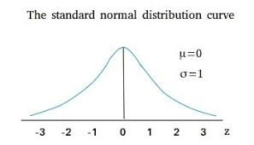**Standard Normal Distribution:** A normal distribution with a mean of zero and a standard deviation of one. The letter z is commonly used to designate this particular normal random variable. we can interpret z as the number of standard deviations that the normal random variable x is from its mean μ. As with other continuous random variables, probability calculations with any normal distribution are made by computing areas under the graph of the probability density function. Thus, to find the probability that a normal random variable is within any specific interval, we must compute the area under the normal curve over that interval. For the standard normal distribution, areas under the normal curve have been computed and are available in tables that can be used to compute probabilities.

$$z=\frac{x-μ}{s}$$

$$f\left(z\right)= \frac{1}{\sqrt{2π}}e^{\frac{{-z}^{2}}{2}}$$

A standard normal distribution table shows a [cumulative probability](https://stattrek.com/Help/Glossary.aspx?Target=Cumulative%20probability) associated with a particular z-score. Table rows show the whole number and tenths place of the z-score. Table columns show the hundredths place. The cumulative probability (often from minus infinity to the z-score) appears in the cell of the table.

To find P(z > a): The probability that a standard normal random variable (z) is greater than a given value (a) is easy to find. The table shows the P(z < a). The P(z > a) = 1 - P(z < a).

To find P(a < z < b): The probability that a standard normal random variables lies between two values is also easy to find. The P(a < z < b) = P(z < b) - P(z < a).

**Approximation of Binomial Distribution using Normal distribution:** A binomial experiment consists of a sequence of n identical independent trials with each trial having two possible outcomes, a success or a failure. The probability of a success on a trial is the same for all trials and is denoted by p. The binomial random variable is the number of successes in the n trials, and probability questions pertain to the probability of x successes in the n trials. When the number of trials becomes large, evaluating the binomial probability function by hand or with a calculator is difficult.

In cases where np $≥$ 5, and n(1 - p) $≥$ 5, the normal distribution provides an easy-to-use approximation of binomial probabilities. When using the normal approximation to the binomial, we set μ = np and σ = $\sqrt{np(1-p)}$ in the definition of the normal curve. Continuity correction factor A value of 0.5 that is added to or subtracted from a value of x when the continuous normal distribution is used to approximate the discrete binomial distribution.

In case where n $≥$ 20 and p $≤$ 0.05, Poisson is a good approximation of binomial. We set μ = np to get the probabilities using Poisson distribution

**Exponential Probability distribution**: A continuous probability distribution that is useful in computing probabilities for the time it takes to complete a task. The exponential distribution is often concerned with the amount of time until some specific event occurs. For example, the amount of time (beginning now) until an earthquake occurs has an exponential distribution. Other examples include the length, in minutes, of long distance business telephone calls, and the amount of time, in months, a car battery lasts. It can be shown, too, that the amount of change that you have in your pocket or purse follows an exponential distribution. Values for an exponential random variable occur in the following way. There are fewer large values and more small values. For example, the amount of money customers spend in one trip to the supermarket follows an exponential distribution. There are more people that spend less money and fewer people that spend large amounts of money. The exponential distribution is widely used in the field of reliability. Reliability deals with the amount of time a product lasts.

In exponential distribution the mean and standard deviation are equal.

$$f\left(x\right)= \frac{1}{μ}e^{\frac{-x}{μ}} for x≥0, μ≥0$$

Exponential Distribution Cumulative Probabilities are given by:

$$P\left(x≤x_{0}\right)=1- e^{\frac{-x_{0}}{μ}}$$

$$P\left(x ≥x_{0}\right)= e^{\frac{-x_{0}}{μ}}$$

$$P\left(x_{0}≤x≤x_{1}\right)= e^{\frac{-x_{0}}{μ}}- e^{\frac{-x_{1}}{μ}}$$

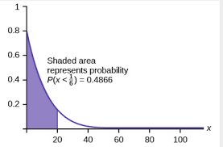

**Relationship between Poisson and Exponential Distribution: If** arrivals follow a Poisson distribution, the time between arrivals must follow Exponential distribution. If the mean no of arrivals/event in unit time is μ follows Poisson distribution then mean time required for next arrival/event is given by 1/μ follows Exponential distribution. If the times between random events follow exponential distribution with rate μ, then the total number of events in a time period of length t follows the Poisson distribution with parameter μt.